Please Check Appropriate Category:
Hand-drawn Digital Braille Additional Assist

2026 NACD/VASWCD
Poster Contest
Local Entry Form
Check the box below if this poster is being submitted to earn the Conservation Poster Scout Patch

Please Check Appropriate Grade Level:
K-1 2-3 4-6 7-9 ____10-12


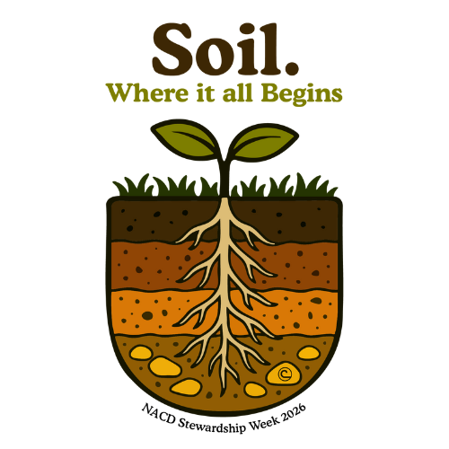
Submit this entry to your local Soil & Water Conservation District
Not familiar with your local SWCD? Find yours here
or Visit www.vaswcd.org for information.
Local deadlines may vary.
PLEASE PLACE THIS DOCUMENT/FORM ON THE BACK OF THE POSTER

STUDENT
Name First: Middle: Last: Address: Students Age: Grade level:

(Address Optional – used to ship certificate/prize to winner)
Please circle one:
Yes or No: This poster is the original work of the student named above.
Yes or No: The student received assistance from another person or materials/ideas from another source. If answered “yes,” please include a brief explanation. Please answer regardless of entry category.

PARENT/GUARDIANS SIGNATURE x DATE

Printed name of parent or guardian name:

Parent/Guardians signature will allow the NACD/the Conservation District listed below to utilize poster submission for educational or promotional purposes.

Email Address Phone Number: ( )

SCHOOL/GROUP/ORGANIZATION
Please choose: Public School Private School Home School Organization Other

Name: Contact: Email Address: Address: City: State: Zip: Phone Number: ( )

CONSERVATION DISTRICT
Name: Contact: Email Address: Address: City: State: Zip: Phone Number: ( )
Questions?
Contact Your Local Soil &Water Conservation District or Byron Minson at
(804) 559-0324 or Byron.minson@vaswcd.org
Virginia Association of Soil & Water Conservation Districts
http://vaswcd.org/poster-contest

NACD ⦁ 509 Capitol Ct, NE ⦁ Washington, DC 20002 ⦁ (202) 547-6223 ⦁ www.nacdnet.org

